|  |  |  |
| --- | --- | --- |
| VILNIAUS KOLEGIJA  UNIVERSITY OF APPLIED SCIENCES  FACULTY OF ELECTRONICS AND INFORMATICS  BURUNDUKAI | | |
| https://screenshotscdn.firefoxusercontent.com/images/eaf3f7f3-2952-4801-af5c-4f20e8ae8b88.png | | |
| **MOCKUP'S HEAURISTIC EVALUATION** | | |
|  | | |
|  | | |
| GROUP WORK  6531BX028 PI18E | | |
| STUDENTS | (SIGNATURE) | EDITA KOMAROVA  SAULĖ STANKEVIČIŪTĖ    MANTAS PODOLSKIS    DŽIUGAS PEČIULEVIČIUS |
| 2019-04 |
| (SIGNATURE) |
| 2019-04 |
| (SIGNATURE) |
| 2019-04 |
| (SIGNATURE) |
| LECTURER | 2019-04 | SVETLANA KUBILINSKIENE | |
|  | (SIGNATURE) |  |
|  | 2019-04 |  |
| 2019 | | |

# ANOTATION

## **Purpose of work**

Purpose of work is to evaluate given system by heuristic evaluation method, evaluate positive and negative aspects of the system and give conclusion to how proceed with the project.

## **Team members contribution**

Edita Komarova – 25%

Saulė Stankevičiūtė – 25%

Mantas Podolskis - 25%

Džiugas Pečiulevičius – 25%

## **Tools used for work**

Microsoft Word and Azure RP 8.

**TABLE OF CONTENTS**

ANOTATION 2

**Purpose of work** 2

**Team members contribution** 2

**Tools used for work** 2

INTRODUCTION 4

**Program system name** 4

**Subject area** 4

**Users** 4

**Problematic area** 4

**1.** **HEURISTIC EVALUATION REPORT** 5

**1.1 Summary** 5

**1.2 Assessment environment** 5

**1.3 Evaluation tasks** 5

**1.4** **Description of positive aspects** 7

**1.5 Analysis of main problem** 9

**1.6 List of deficiencies found** 26

**1.7 Conclusion** 30

**TABLE OF FIGURES**

Picture 1 - Functions visible on the first glance 8

Picture 2 - Good aesthetics 8

Picture 3 - Recognition 8

Picture 4 - Error prevention 9

Picture 5 - Mapping 9

Picture 6 - Register to the system 10

Picture 7 - Main page 10

Picture 8 - Reset password 11

Picture 9 - Search buttons 11

Picture 10 - Drop-down lists 12

Picture 11 - Unpressable buttons 13

Picture 12 - Recommended page 13

Picture 13 - Recommended main page 14

Picture 14 - Recommended page 2 14

Picture 15 - Description 15

Picture 16 - Buttons 15

Picture 17 - Buttons 2 16

Picture 18 - Arrows 16

Picture 19 - Scroll 17

Picture 20 - Send button 17

Picture 21 - Print button 18

Picture 22 - Add notes button 18

Picture 23 - Favorite button 19

Picture 24 - Remove account button 19

Picture 25 - Change page window 20

Picture 26 - Add contact window 20

Picture 27- User account 21

Picture 28 - Favorite lists buttons 22

Picture 29 - Creating a new lists 22

Picture 30 - Listing error 23

Picture 31 - Edit listing 23

Picture 32 - Edit two listings 24

Picture 33 - Delete listings 24

Picture 34 - Check engagement 25

Picture 35 - No header buttons 25

Picture 36 - Footer buttons not working 26

Picture 37 - There's no navigation bar 26

# INTRODUCTION

## **Program system name**

Real-Estate JAM (REJ).

## **Subject area**

Website for finding real estate to rent, let, buy or sell.

## **Users**

Users must have a basic knowledge of how to use a web browser and the internet.

Administrators must have expert level understanding of the system and computer skills.

## **Problematic area**

Reducing time of finding appropriate place to rent, let, buy or sell.

1. **HEURISTIC EVALUATION REPORT**
   1. **Summary**

This heuristic evaluation started by examining system by each team member, that took approximately two hours. Experts were introduced to Real-Estate JAM (REJ) by reading “The needs of the users for designed system program: Real-Estate JAM (REJ)”. Each one of the experts tried out different features and tried out all of the main tasks. Which were presented in their hierarchical task analysis.

After that each expert written down all found deficiencies and compared them with other ones that other experts have found. Then they filled in tables with all negative and all positive functions. All experts agree that that general problems are mostly visibility and feedback. There were also mapping mistakes, however there were not a lot of mapping mistakes. Most of the problems was about visibility system status. Where you wouldn’t know if the action you took was successful or not. 4 cosmetic deficiency, 10 small deficiencies, 6 serious deficiencies and 6 critical flaws. The biggest problem in experts opinion was simply buttons not working, or reacting to any action. Otherwise system has a few positive aspects such as minimalistic design or recognition.

* 1. **Assessment environment**

|  |  |  |  |  |
| --- | --- | --- | --- | --- |
| Evaluator | Džiugas Pečiulevičius | Mantas Podolskis | Saulė Stankevičiūtė | Edita Komarova |
| Code | DP | MP | SS | EK |
| Age | 21 | 23 | 19 | 19 |
| Sex | Male | Male | Female | Female |
| Evaluation time and date | 2019-04-17 11:45 | 2019-04-18 14:15 | 2019-04-17 13:00 | 2019-04-18 16:35 |
| Operating system | Windows 10 | Windows 10 | Windows 10 | Windows 10 |
| Browser | Google Chrome | Google Chrome | Google Chrome | Firefox |
| Display size  (in inches) | 15.6” | 15.6” | 15.6” | 15.6” |
| Resolution | 1920x1080 | 1920x1080 | 1920x1080 | 1920x1080 |

Table 1 - Assessment environment

## **Evaluation tasks**

1. Create user account.
   1. Enter Username in required field.
   2. Enter email address in field “Email”.
   3. Enter password in field “Password”.
   4. Re-enter password in field “Confirm password”.
2. Login to the account.
   1. Enter username in field “Username”.
   2. Enter password in field “Password”.
   3. Get password reminder.
      1. Enter username.
      2. Enter E-mail address.
3. Access Real-estate listings.
   1. Search for listings
      1. Enter keyword in “Search by State, City or Suburb” field.
      2. Enter postcode in “Search by Postcode” field.
      3. Apply filters to search results.
   2. Browse listings without searching.
   3. View recommended property listings.
   4. View favorite listings.
   5. View listing details.
      1. Print listing details.
      2. Add personal notes to said listing.
      3. Add listing to favorites.
4. Control your user account.
   1. Click “Profile management” button.
      1. Delete your user account.
      2. Edit your user account information.
         1. Change password.
         2. Add contact information.
      3. View search history.
      4. View favorited property listings.
         1. Delete listing from favorites.
      5. Control your property listings.
         1. Create new property listing.
            1. Enter Property information.
         2. Select your existing property listing.
            1. Edit property listing.
            2. Delete property listing.
            3. Check user engagement on their property listings.
5. Administrative privileges and tasks.
   1. Administrator must be able to find a specific user.
      1. Delete or ban user account.
      2. Unban or restore user account.
      3. Send private message / notice to user.
      4. Access users created listings.
         1. Delete or modify a listing.
         2. Restore listing deleted by the user.
         3. Hide listing from appearing in search.
         4. Add listing to recommended section.
   2. Administrator must be able to find specific listing.
      1. Delete or modify a listing.
      2. Hide listing from appearing in search.
      3. Add listing to recommended section.
6. Logout from the account.
   1. Press “Sign out”.

## **Description of positive aspects**

|  |  |
| --- | --- |
| **Description** | **Visual fragment** |
| (Minimalistic design)  All the necessary functions are visible on the first glance at the page. | Picture 1 - Functions visible on the first glance |
| (Aesthetic and minimalistic design)  Search filters do not clog the page, you can see the options in drop boxes. | Picture 2 - Good aesthetics |
| (Recognition)  It is clear that you can click on the options, as they are underlined and there is a down-facing triangle besides the drop-box title. | Picture 3 - Recognition |
| (Error prevention)  Password is requested whenever you try to delete your listing, making it hard to do it by accident. | Picture 4 - Error prevention |
| (Error recovery, consistency)  In case you make a mistake in your listing information during its creation, you can easily edit.  The edit table has the same settings as creation table. |  |
| (Mapping)  Universal buttons for “Favorite” and “Exit” | Picture 5 - Mapping |

## **1.5 Analysis of main problem**

1) **Task:** 1. Register to the system

**Found by:** DP, SS, EK, MP.

**Violated principle:** *Feedback*

There’s no prompt message for the user showing (un)successful registration.

**Picture:**

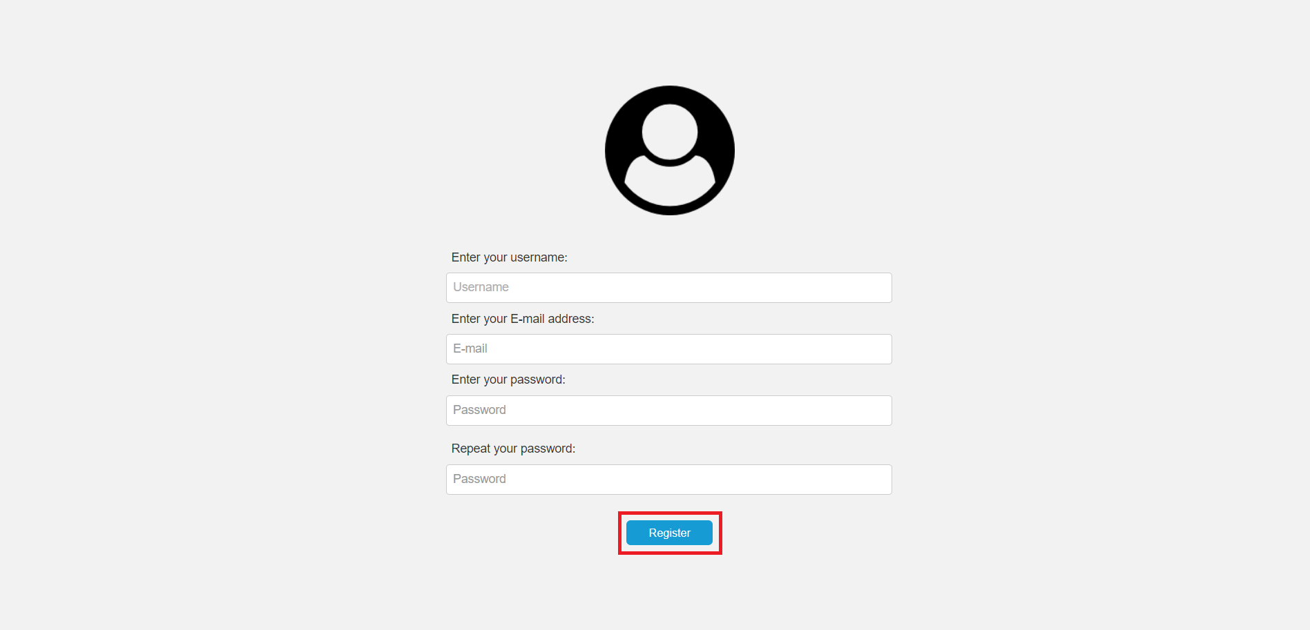

Picture 6 - Register to the system

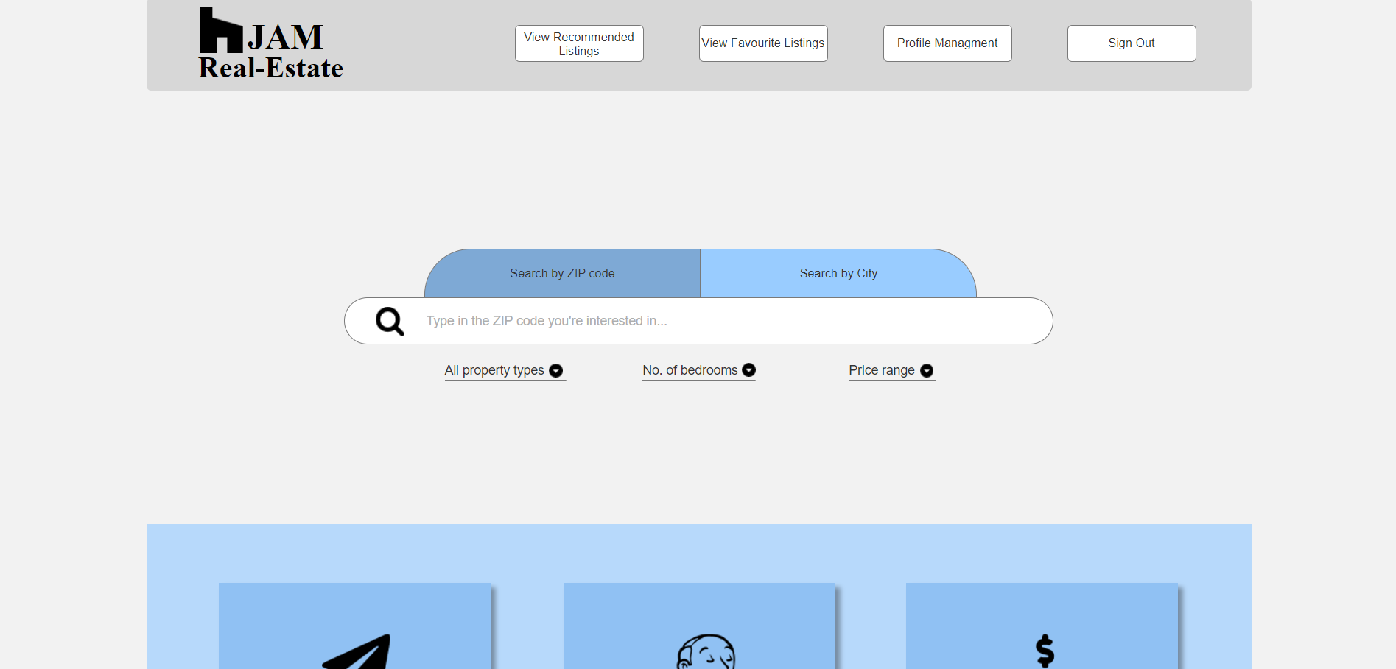

Picture 7 - Main page

2) **Task:** 2.3. Get password reminder

**Found by:** DP, SS, EK, MP.

**Violated principle:** *Feedback*

There’s no prompt message for the user showing that the password has been sent to an email address.

**Picture:**

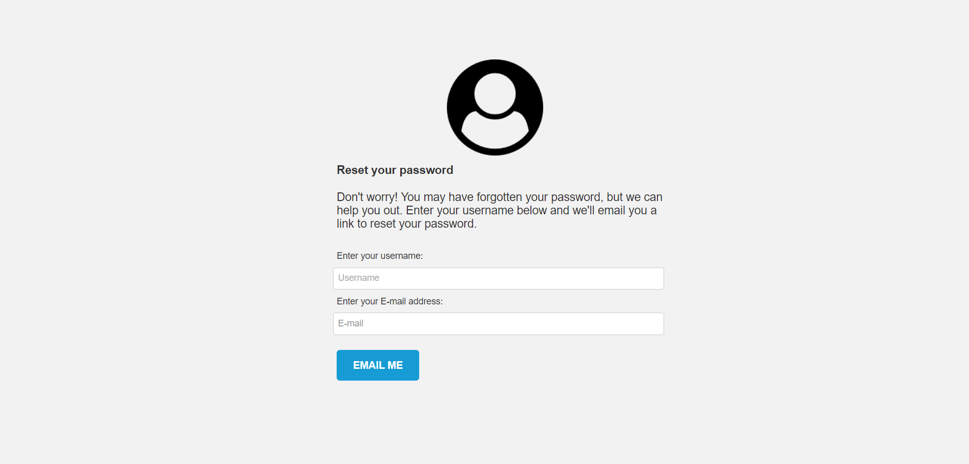

Picture 8 - Reset password

3) **Task:** 3.1. Search for listings.

**Found by:** MP.

**Violated principle:** *Visibility*

If you click any of these buttons (Search by ZIP or by City) twice, it won’t show that its selected anymore.

**Picture:**

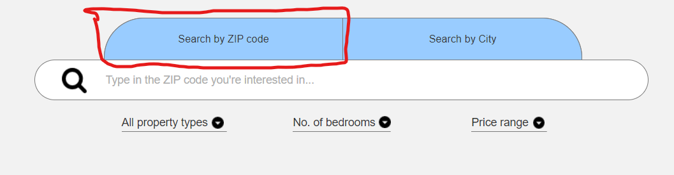

Picture 9 - Search buttons

4) **Task:** 3.1.3. Apply filters to search results.

**Found by:** DP, SS, EK, MP.

**Violated principle:** *Freedom of user control*

You have to click on the dropdown menus, but they actually don’t stay up, they disappear when I move my cursor of.

**Picture:**

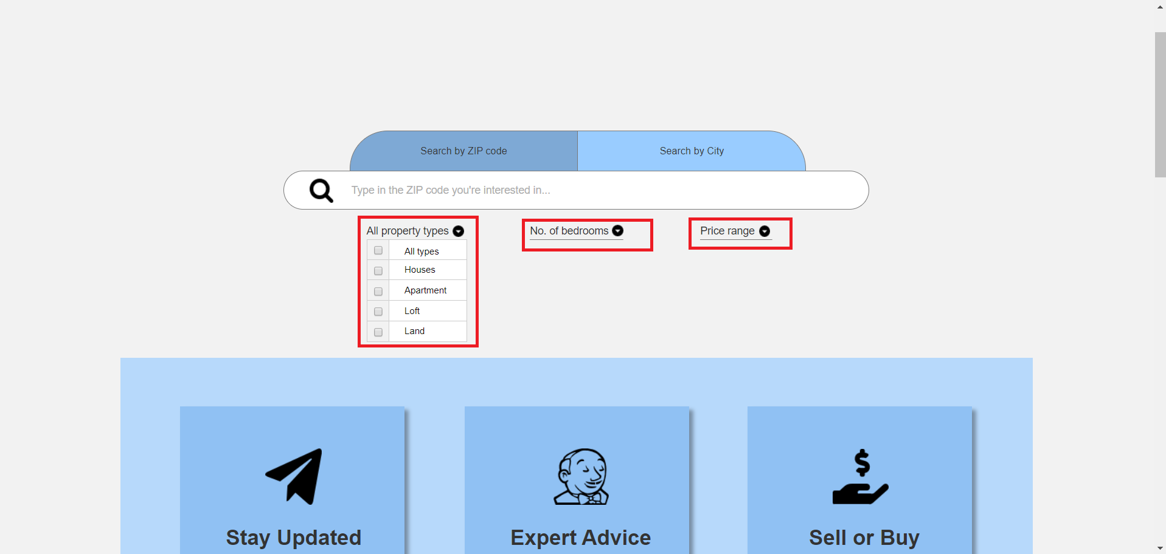

Picture 10 - Drop-down lists

5) **Task:** 3.2. Browse listings without searching.

**Found by:** DP, SS, EK, MP.

**Violated principle:** *Mapping*

Below drop-down menus, and above 'recommended' there are sections like "stay updated", "Expert advice", and "Sell or buy". They look like buttons, but they are actually not, would change the appearance or maybe just add a button to click and bring the user to the exact page which is named in the box.

**Picture:**

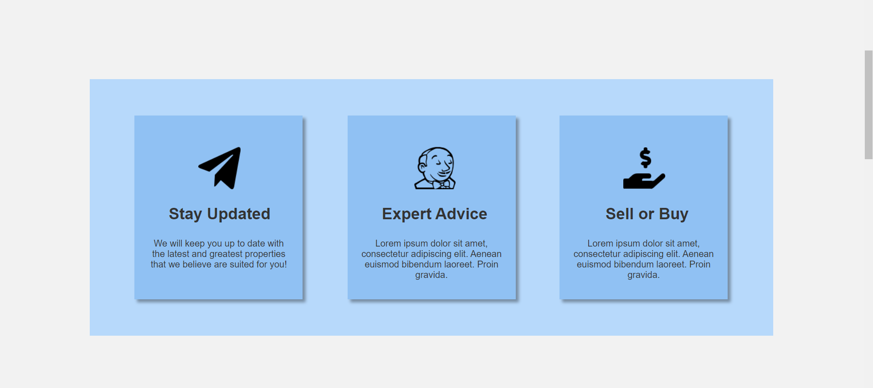

Picture 11 - Unpressable buttons

6) **Task:** 3.3. View recommended property listings.

**Found by:** DP, SS, EK, MP.

**Violated principle:** Mapping, Consistency.

For the section where all the houses are, below each photo of a flat, it would be nice to make text and price clickable just as the photo. Also these recommended lists are not the same. Also the information shown is different in both of these recommended lists.

**Picture:**

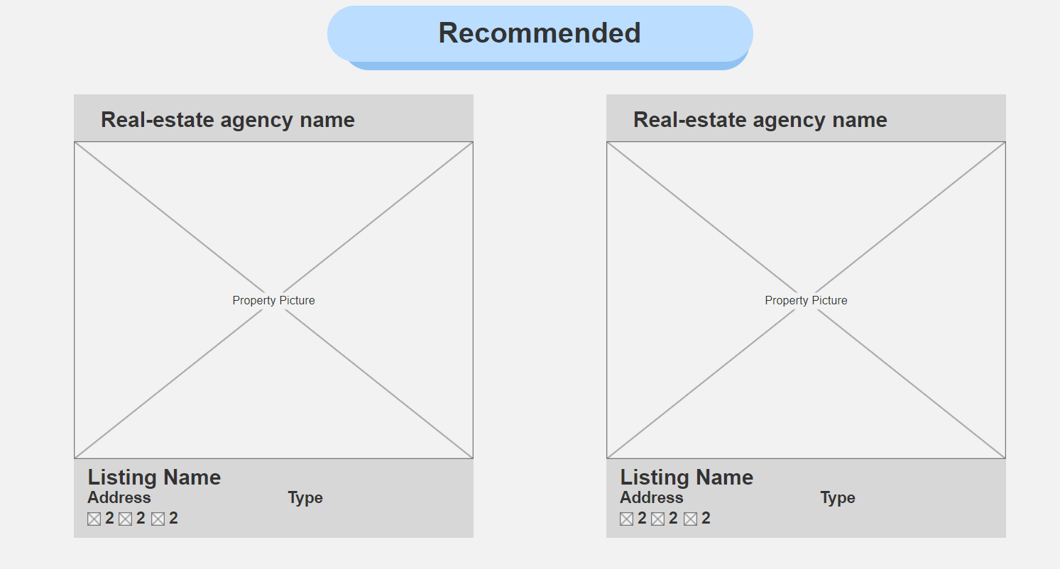

Picture 12 - Recommended page

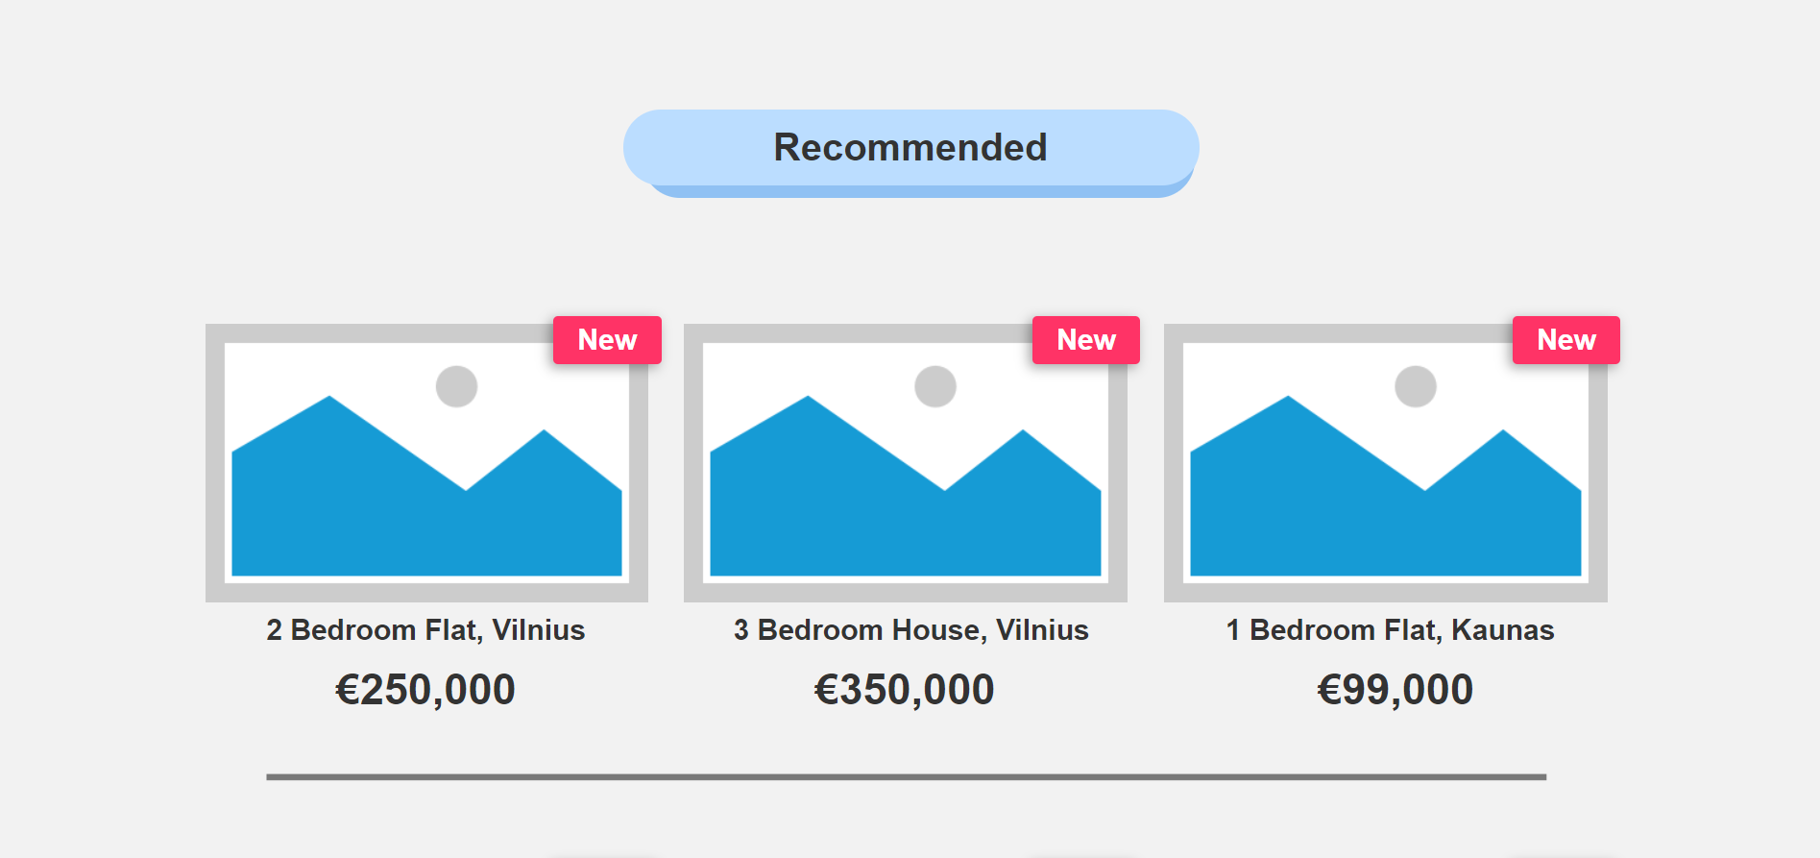

Picture 13 - Recommended main page

7) **Task:** 3.4. View favorite listings.

**Found by:** DP, SS, EK, MP.

**Violated principle:** *Consistency*

This does not show what is supposed to be instead of these small icons.

**Picture:**

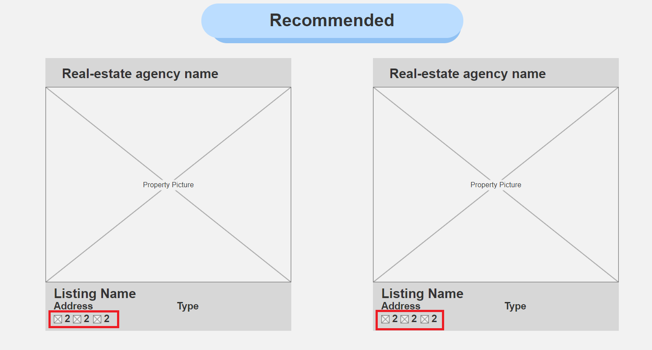

Picture 14 - Recommended page 2

8) **Task:** 3.5. View listing details.

**Found by:** DP, SS, EK, MP.

**Violated principle:** *Consistency*

Prices are in dollars and euros.

**Picture:**

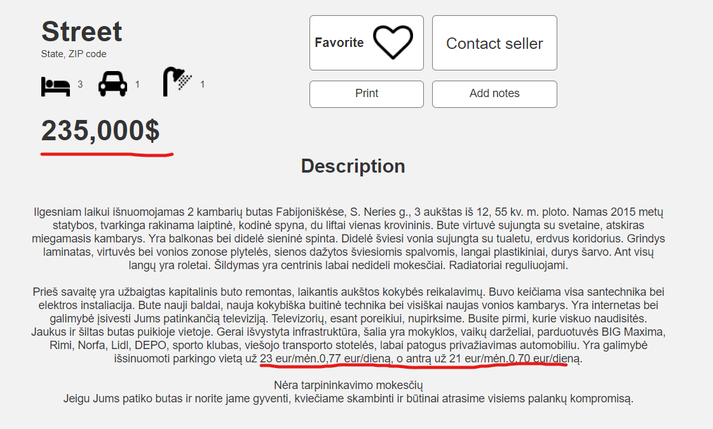

Picture 15 - Description

9) **Task:** 3.5. View listing details.

**Found by:** DP, SS.

**Violated principle:** *Consistency*

Buttons are laid out differently on the page where user is logged from the page where user is logged off.

**Picture:**

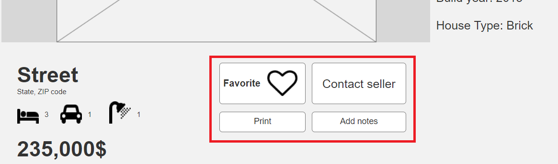

Picture 16 - Buttons

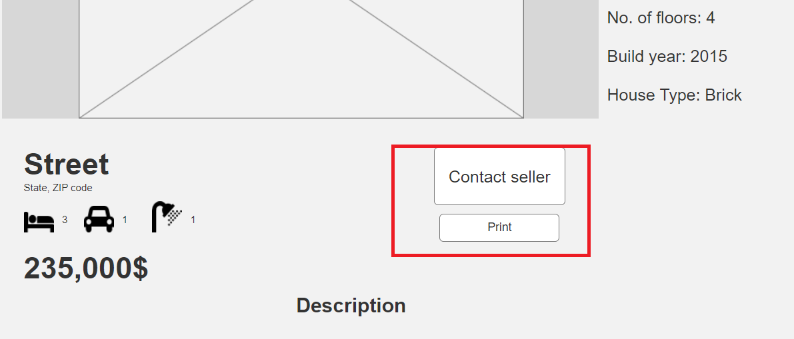

Picture 17 - Buttons 2

10) **Task:** 3.5. View listing details.

**Found by:** DP, SS, MP.

**Violated principle:** *Visibility*

There are no arrows to scroll through the photos.

**Picture:**

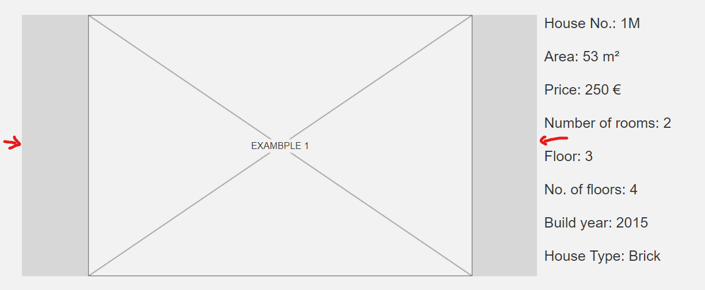

Picture 18 - Arrows

11) **Task:** 3.5. View listing details.

**Found by:** DP, SS, EK, MP.

**Violated principle:** *Flexibility*

When scrolling through, photos slide to the opposite direction

**Picture:**

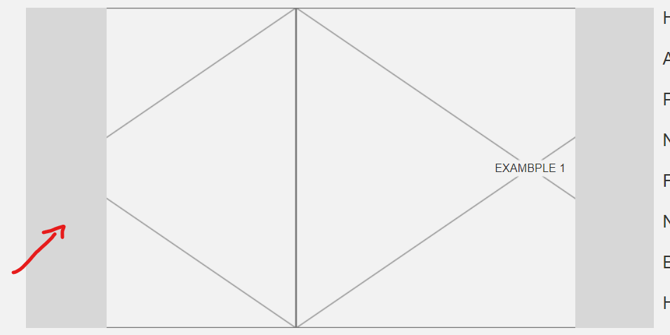

Picture 19 - Scroll

12) **Task:** 3.5. View listing details.

**Found by:** DP, SS, EK, MP.

**Violated principle:** *Visibility of system status*

There's no prompt that the message has been sent after clicking on 'Contact seller' -> 'Send'

**Picture:**

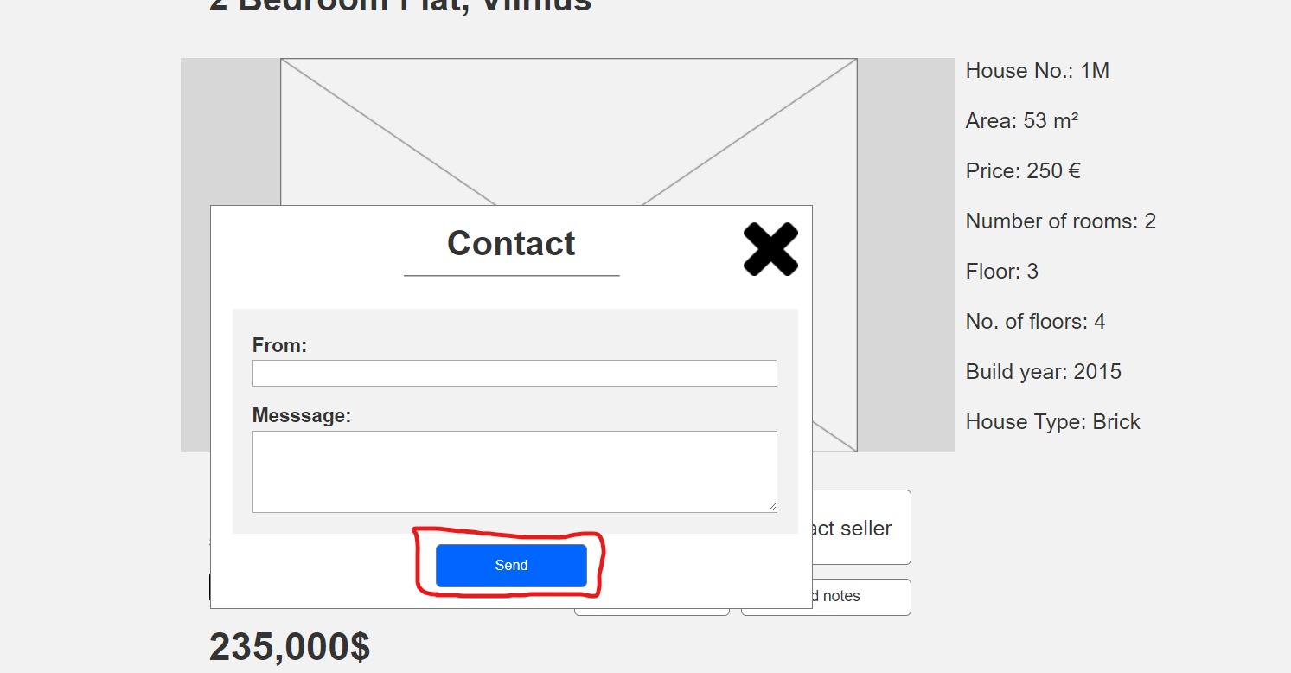

Picture 20 - Send button

13) **Task:** 3.5.1. Print listing details.

**Found by:** DP, SS, EK, MP.

**Violated principle:** *Feedback*

Print button is not clickable and there's no prompt showing the user that anything is happening.

**Picture:**

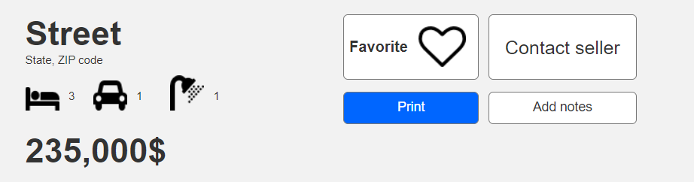

Picture 21 - Print button

14) **Task:** 3.5.2. Add personal notes to said listing.

**Found by:** DP, SS, EK, MP.

**Violated principle:** *Feedback*

“Add notes” doesn’t work and does not provide user with any output information.

**Picture:**

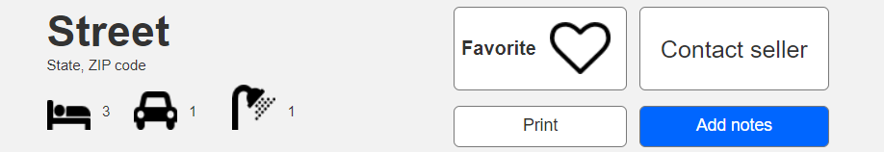

Picture 22 - Add notes button

15) **Task:** 3.5.3. Add listing to favorites.

**Found by:** DP.

**Violated principle:** *Feedback*

I cannot click on the button properly, only on the heart.

**Picture:**

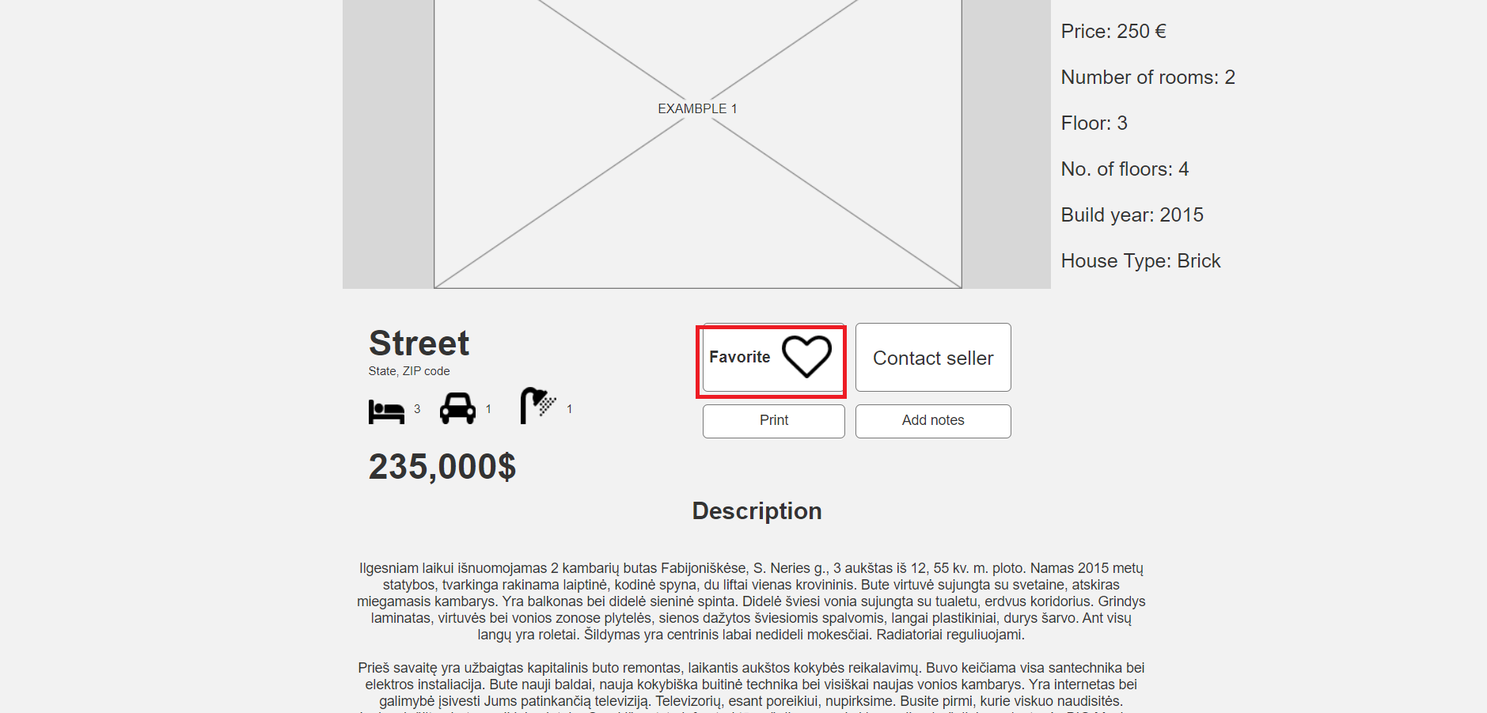

Picture 23 - Favorite button

16) **Task:** 4.1.1. Delete your user account.

**Found by:** EK.

**Violated principle:** *Feedback*

Nothing happens after clicking “Yes, remove my account”

**Picture:**

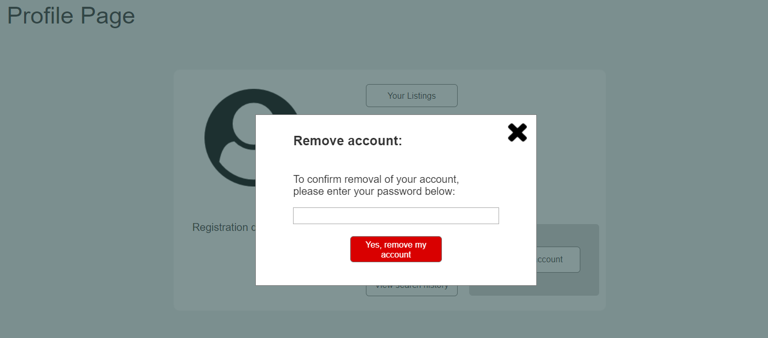

Picture 24 - Remove account button

17) **Task:** 4.1.2.1. Change password.

**Found by:** DP, SS, EK, MP.

**Violated principle:** *Visibility of system status*

It doesn’t give any prompt that the password has been changed or that an email has been sent to a personal email.

**Picture:**

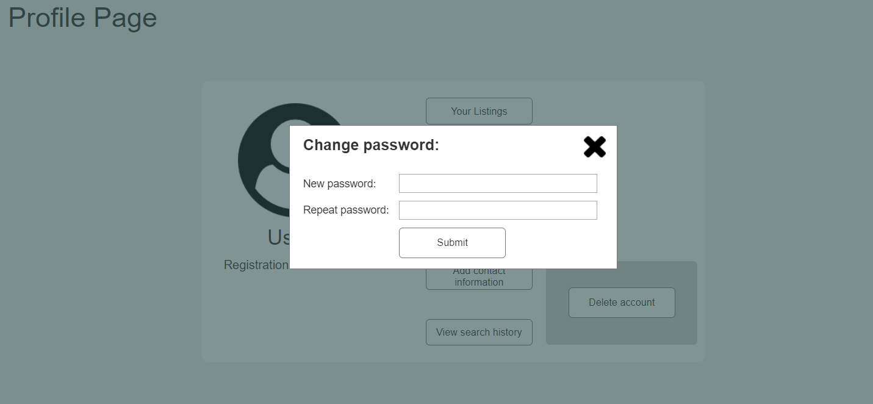

Picture 25 - Change page window

18) **Task:** 4.1.2.2. Add contact information.

**Found by:** DP, SS, EK, MP.

**Violated principle:** *Visibility of system status*

It doesn't give user any prompt that the information has been added.

**Picture:**

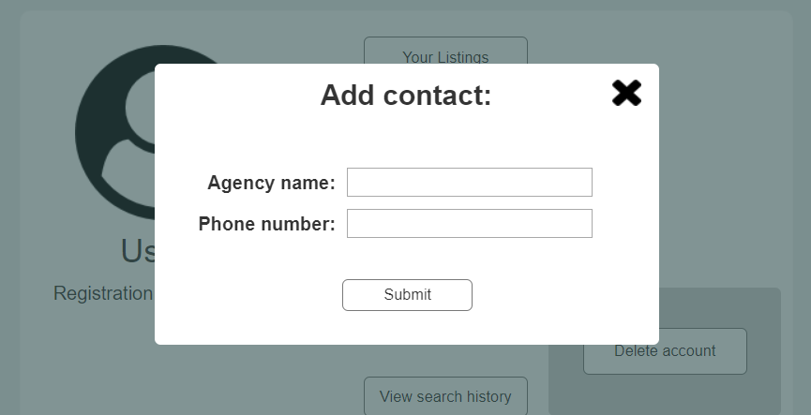

Picture 26 - Add contact window

19) **Task:** 4.1.2.2. Add contact information.

**Found by:** DP, SS, EK, MP.

**Violated principle:** *Feedback*

There’s no way to edit or delete personal information. Better way would be to add a different page for personal information where it can be easily accessed and edited if needed.

**Picture:**

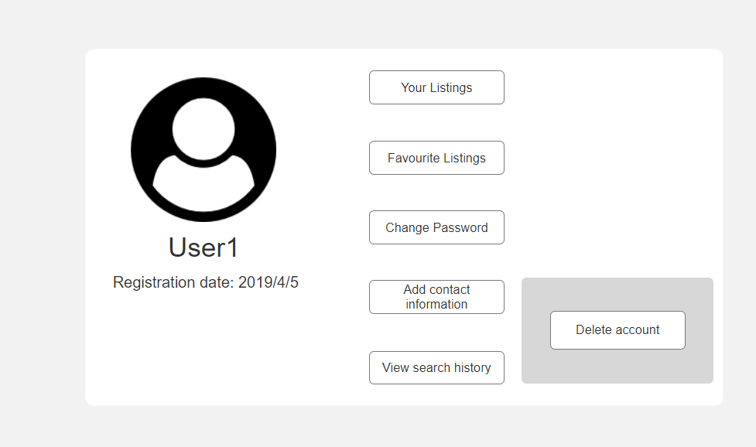

Picture 27- User account

20) **Task:** 4.1.4.1. Delete listing from favorites.

**Found by:** DP, SS, EK, MP.

**Violated principle:** *Recognition, Mapping, Minimalism*

After clicking on the heart it should either give a prompt that it asks a user to confirm an action. Did not see that the confirmation appeared just below an actual listing.

**Picture:**

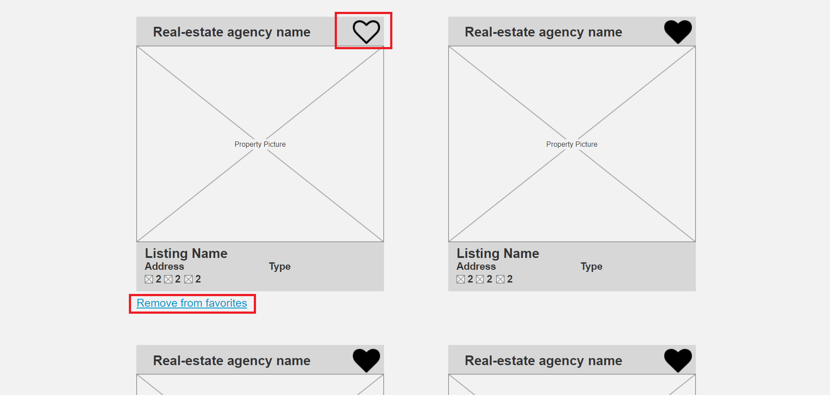

Picture 28 - Favorite lists buttons

21) **Task:** 4.1.5.1. & 4.1.5.1.1. Create new property listing & Enter property information.

**Found by:** DP, SS, EK, MP.

**Violated principle:** *Feedback*

Create a new listing -> Create -> It either creates a listing and it’s all over the place or it doesn’t create anything. When you delete them or refresh the page, you cannot create any new listings.

**Picture:**

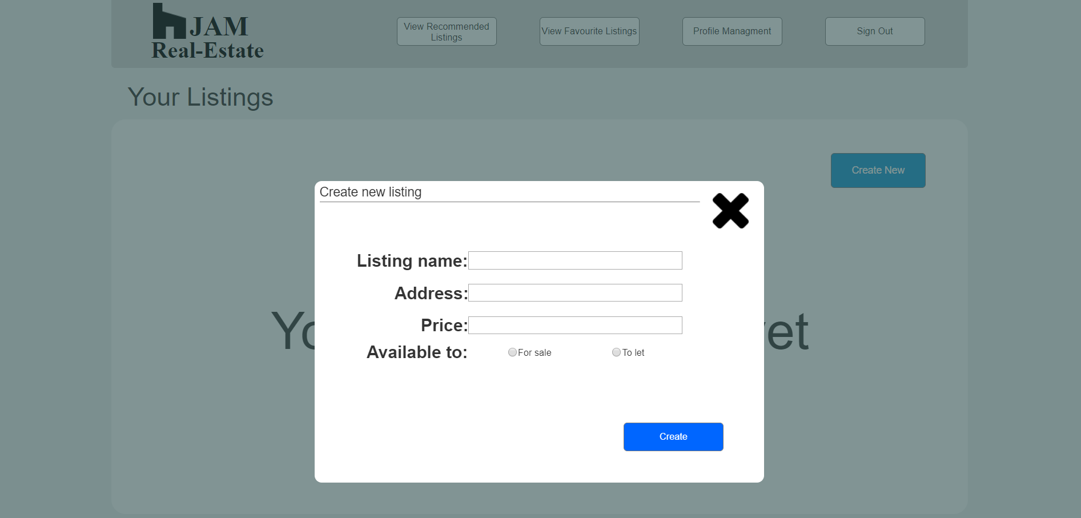

Picture 29 - Creating a new lists

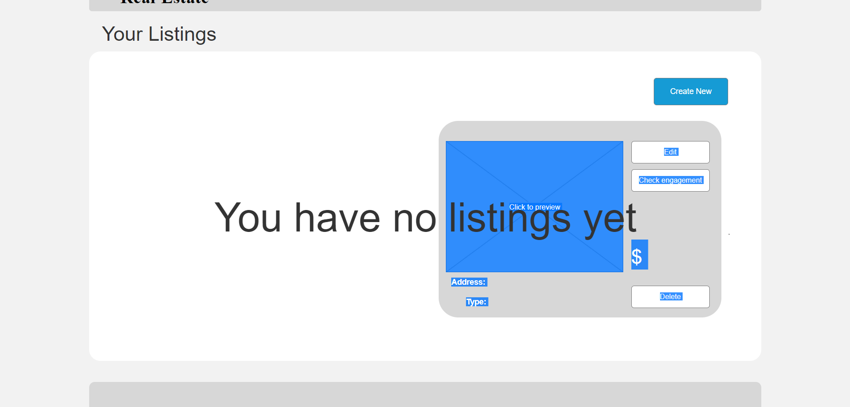

Picture 30 - Listing error

22) **Task:** 4.1.5.2.1. Edit property listing.

**Found by:** SS.

**Violated principle:** *Flexibility*

You can open 2 edit windows at once.

**Picture:**

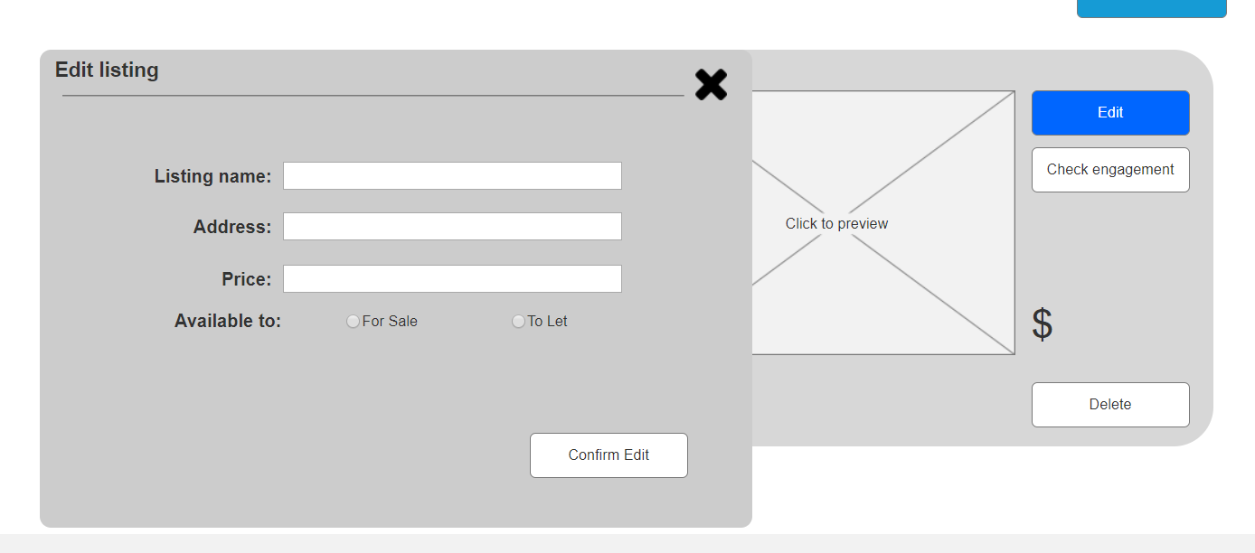

Picture 31 - Edit listing

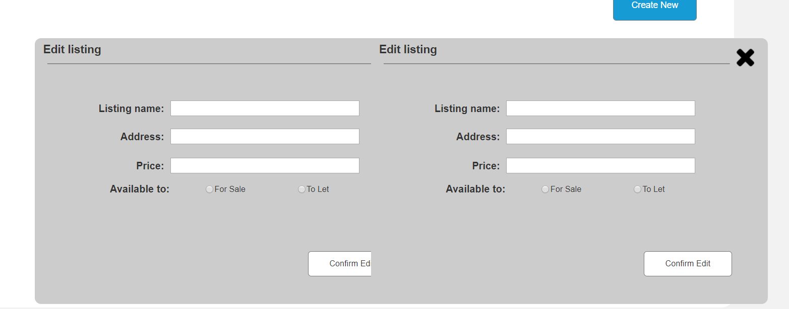

Picture 32 - Edit two listings

23) **Task:** 4.1.5.2.2. Delete property listing.

**Found by:** DP, SS, EK, MP.

**Violated principle:** *Feedback*

After clicking on “Yes, delete my listing”, nothing happens.

**Picture:**

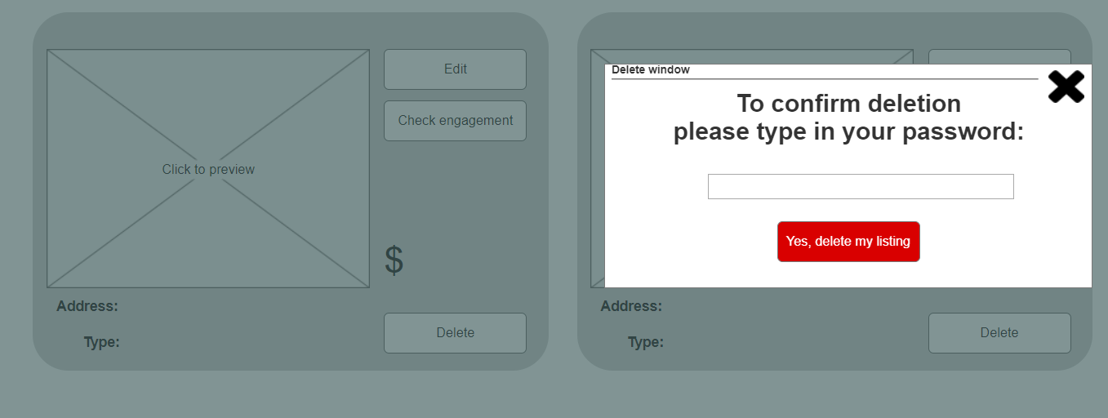

Picture 33 - Delete listings

24) **Task:** 4.1.5.2.3. Check user engagement on their property listings..

**Found by:** DP, SS, EK, MP.

**Violated principle:** *Feedback*

Check engagement buttons are not working and no actions are performed.

**Picture:**

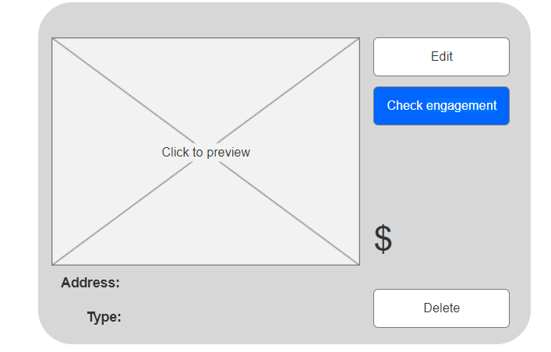

Picture 34 - Check engagement

25)

**Found by:** DP, SS, EK, MP.

**Violated principle:** *Consistency*

There’s no way to access recommended listings from the profile page.

**Picture:**

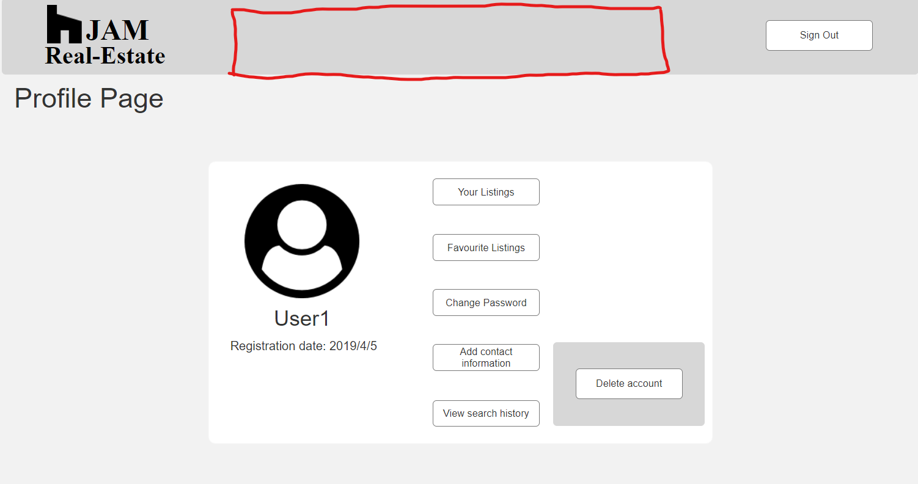

Picture 35 - No header buttons

26)

**Found by:** DP, MP.

**Violated principle:** *Feedback*

No information is provided when clicked on any of the legal buttons

**Picture:**



Picture 36 - Footer buttons not working

27)

**Found by:** SS, EK.

**Violated principle:** *Freedom navigation*

It’s hard for user to understand where user is right now. There’s no navigation bar.

**Picture:**

Annotation 2019-04-23 104223

Picture 37 - There's no navigation bar

## **1.6 List of deficiencies found**

|  |  |
| --- | --- |
| **Difficulty** | **Meaning** |
| 4 | Critical flaw |
| 3 | Serious deficiency |
| 2 | Small deficiency |
| 1 | Cosmetic deficiency |
| 0 | No problem |
| Average | Average estimates |

Table 2 - List of deficiencies found

Fourth table contains list and ranking of deficiencies found.

|  |  |  |  |  |  |  |  |  |  |  |  |
| --- | --- | --- | --- | --- | --- | --- | --- | --- | --- | --- | --- |
| **No.** | **Description** | **Found by** | | | | **Difficulty** | | | | **Average** | **Location** |
| DP | MP | SS | EK | DP | MP | SS | EK |
|  | There’s no prompt message for the user showing (un)successful registration. | + | + | + | + | 4 | 4 | 3 | 3 | 3.5 | Sign-up page |
|  | There’s no prompt message for the user showing that the password has been sent to an email address. | + | + | + | + | 4 | 4 | 3 | 4 | 3.75 | Password reset page |
|  | If you click any of these buttons (Search by ZIP or by City) twice, it won’t show that its selected anymore. |  | + |  |  | 2 | 1 | 2 | 1 | 1.5 | Main page, search page |
|  | You have to click on the dropdown menus, but they actually don’t stay up, they disappear when I move my cursor of. | + | + | + | + | 3 | 2 | 2 | 2 | 2.25 | Main page, search page |
|  | Below drop-down menus, and above 'recommended' there are sections like "stay updated", "Expert advice", and "Sell or buy". They look like buttons, but they are actually not, would change the appearance or maybe just add a button to click and bring the user to the exact page which is named in the box. | + | + | + | + | 3 | 3 | 1 | 2 | 2.25 | Main page |
|  | For the section where all the houses are, below each photo of a flat, it would be nice to make text and price clickable just as the photo. Also these recommended lists are not the same. Also the information shown is different in both of these recommended lists. | + | + | + | + | 1 | 1 | 1 | 1 | 1 | Recommended page |
|  | This does not show what is supposed to be instead of these small icons. | + | + | + | + | 2 | 1 | 2 | 1 | 1.5 | Recommended page |
|  | Prices are in dollars and euros. | + | + | + | + | 1 | 0 | 1 | 0 | 0.5 | Product page |
|  | Buttons are laid out differently on the page where user is logged from the page where user is logged off. | + |  | + |  | 2 | 1 | 2 | 2 | 1.75 |  |
|  | There are no arrows to scroll through the photos. | + | + | + |  | 2 | 2 | 1 | 1 | 1.5 | Product page |
|  | When scrolling through, photos slide to the opposite direction. | + | + | + | + | 2 | 2 | 1 | 1 | 1.5 | Product page |
|  | There's no prompt that the message has been sent after clicking on 'Contact seller' -> 'Send' | + | + | + | + | 4 | 4 | 3 | 4 | 3.75 | Product page |
|  | Print button is not clickable and there's no prompt showing the user that anything is happening. | + | + | + | + | 3 | 3 | 3 | 3 | 3 | Product page |
|  | “Add notes” doesn’t work and does not provide user with any output information. | + | + | + | + | 3 | 3 | 3 | 3 | 3 | Product page |
|  | I cannot click on the button properly, only on the heart. | + |  |  |  | 2 | 2 | 2 | 2 | 2 | Product page |
|  | Nothing happens after clicking “Yes, remove my account” |  |  |  | + | 3 | 3 | 3 | 3 | 3 | Profile page |
|  | It doesn’t give any prompt that the password has been changed or that an email has been sent to a personal email. | + | + | + | + | 3 | 3 | 3 | 3 | 3 | Profile page |
|  | It doesn't give user any prompt that the information has been added. | + | + | + | + | 3 | 3 | 3 | 3 | 3 | Profile page |
|  | There’s no way to edit or delete personal information. Better way would be to add a different page for personal information where it can be easily accessed and edited if needed. | + | + | + | + | 3 | 2 | 3 | 2 | 2.5 | Profile page |
|  | After clicking on the heart it should either give a prompt that it asks a user to confirm an action. Did not see that the confirmation appeared just below an actual listing. | + | + | + | + | 2 | 1 | 2 | 2 | 1.75 | Favorites page |
|  | Create a new listing -> Create -> It either creates a listing and it’s all over the place or it doesn’t create anything. When you delete them or refresh the page, you cannot create any new listings. | + | + | + | + | 4 | 4 | 4 | 4 | 4 | User's listings page |
|  | You can open 2 edit windows at once. |  |  | + |  | 2 | 3 | 2 | 2 | 2.25 | User's listings page |
|  | After clicking on “Yes, delete my listing”, nothing happens. | + | + | + | + | 4 | 4 | 4 | 3 | 3.75 | User's listings page |
|  | Check engagement buttons are not working and no actions are performed. | + | + | + | + | 4 | 3 | 3 | 4 | 3.5 | User's listings page |
|  | There’s no way to access recommended listings from the profile page. | + | + | + | + | 0 | 0 | 1 | 1 | 0.5 | Profile page |
|  | No information is provided when clicked on any of the legal buttons. | + | + |  |  | 0 | 0 | 0 | 0 | 0 | Main page |
|  | It’s hard for user to understand where user is right now. There’s no navigation bar. |  |  | + | + | 2 | 1 | 1 | 1 | 1.25 | Main page |

Table 3 ­- Lists and ranking deficiencies

## **1.7 Conclusion**

Main issues with the interface were visibility, consistency, mapping and user control and freedom. As well as there were some critical flaws that found to be braking the system.

The majority of the problems were small deficiency category with 38,46%. Other 23,07% each were critical and serious deficiencies, and rest 15,38% were categorized as cosmetic deficiencies.

The most impactful deficiency was the non working buttons, which breaks the user control and freedom principle.